Hadoop

Hadoop is an open source software programming framework for storing a large amount of data and performing the computation.

Hadoop framework/Architecture is made up of the following modules:
- Hadoop MapReduce- a MapReduce programming model for handling and processing large data.
- Hadoop Distributed File System- distributed files in clusters among nodes.
- Hadoop YARN- a platform which manages computing resources.
- Hadoop Common- it contains packages and libraries which are used for other modules.
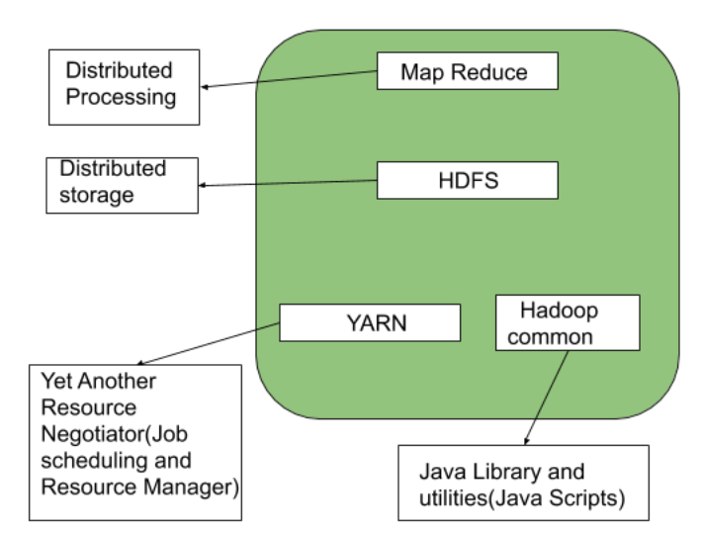

HDFS (Hadoop Distributed File System)

It has distributed file system known as HDFS and this HDFS splits files into blocks and sends them across various nodes in form of large clusters.HDFS in Hadoop provides Fault-tolerance and High availability to the storage layer and the other devices present in that Hadoop cluster.

Hadoop also supports a wide range of software packages such as Apache Flumes, Apache Oozie, Apache HBase, Apache Sqoop, Apache Spark, Apache Storm, Apache Pig, Apache Hive, Apache Phoenix, Cloudera Impala.

Data storage Nodes in HDFS:

HDFS operates in a master-worker architecture, this means that there are one master node and several worker nodes in the cluster. The master node is the Namenode and the Slave/Worker Node is the Datanode.

Namenode:
Namenode is mainly used for storing the Metadata, which is the data about the data.
Meta Data can be the transaction logs that keep track of the user’s activity in a Hadoop cluster.
Meta Data can also be the name of the file, size, and the information about the location(Block number, Block ids) of Datanode that Namenode stores to find the closest DataNode for Faster Communication. Namenode instructs the DataNodes with the operation like delete, create, Replicate, etc.
All this information is maintained persistently over the local disk in the form of two files:
- Fsimage stores the information about the files and directories in the filesystem. For files, it stores the replication level, modification and access times, access permissions, blocks the file is made up of, and their sizes. For directories, it stores the modification time and permissions.
- Edit log on the other hand keeps track of all the write operations that the client performs. This is regularly updated to the in-memory metadata to serve the read requests.
Datanode:
DataNodes works as a Slave DataNodes are mainly utilized for storing the data in a Hadoop cluster
the number of DataNodes can be from 1 to 500 or even more than that. The more number of DataNode, the Hadoop cluster will be able to store more data.

Secondary Namenode is another node present in the cluster whose main task is to regularly merge the Edit log with the Fsimage and produce check‐points of the primary’s in-memory file system metadata. This is also referred to as Checkpointing.

File Block in HDFS:
Data in HDFS is always stored in terms of blocks. So the single block of data is divided into multiple blocks of size 128MB which is default and you can also change it manually.
Racks in Hdfs:
The rack is a physical collection of nodes in our Hadoop cluster (maybe 30 to 40). A large Hadoop cluster is consists of many Racks.
With the help of this Racks information, Namenode chooses the closest Datanode to achieve maximum performance while performing the read/write information. This concept of choosing the closest data node for serving a purpose is Rack Awareness.
Replication In HDFS:
Replication ensures the availability of the data. Replication is making a copy of something and the number of times you make a copy of that particular thing can be expressed as it’s Replication Factor. By default, the Replication Factor for Hadoop is set to 3 which can be configured

Data Locality in Hadoop:
Data locality in Hadoop is the process of moving the computation close to where the actual data resides instead of moving large data to computation. This minimizes overall network congestion. This also increases the overall throughput of the system.
The various categories in Hadoop Data Locality are as follows:

1. Data local data locality in Hadoop:
In this, data is located on the same node as the mapper working on the data. In this, the proximity of data is very near to computation. Data local data locality is the most preferred scenario.
2. Intra-Rack data locality:
In this case, it is preferred to run the mapper on the different node but on the same rack.
3.Inter-Rack data locality:

Sometimes it is also not possible to execute mapper on a different node in the same rack. In such situation, we will execute the mapper on the nodes on different racks.

